**Sample Dotnet console application**

**INTERFACE**

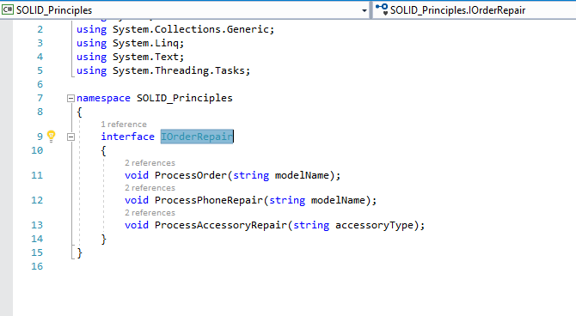

**CLASS with interface implementation**

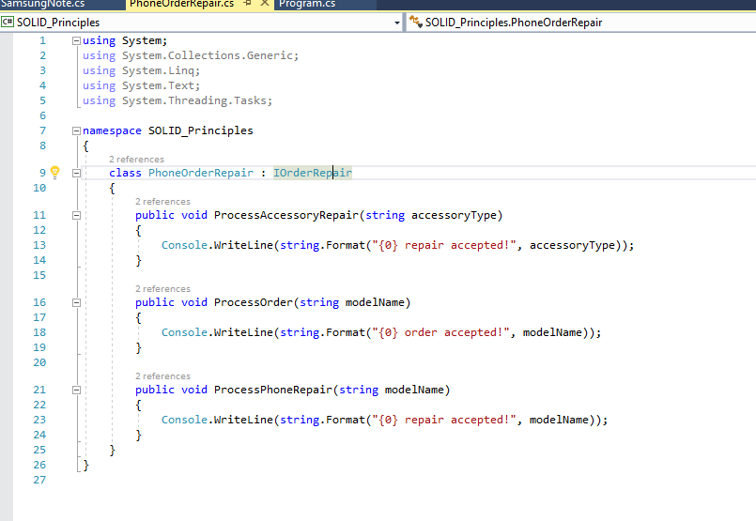

**Console application invoking the class**

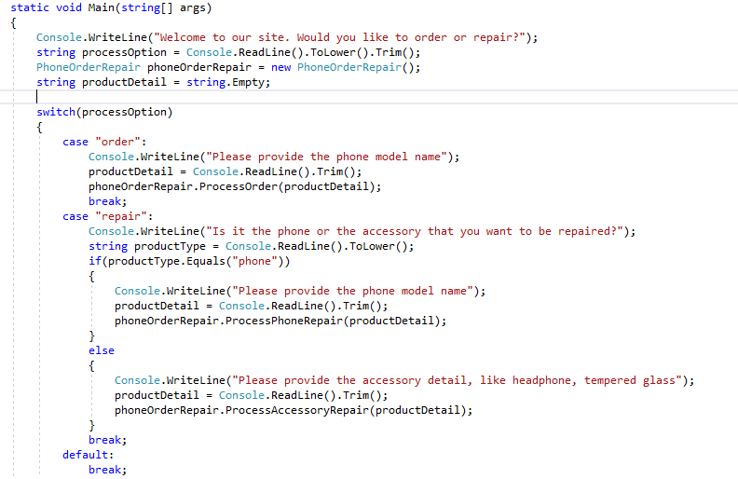

**Instructions**

Please go thru the above Interface, class and implementation. Discuss with your peer and present it to the trainer as to how the class and interface can be modified using the Single responsibility and Interface segregation principles.

**Dependency Inversal – Example explaining the Dependency inversal principle**

**Interface**

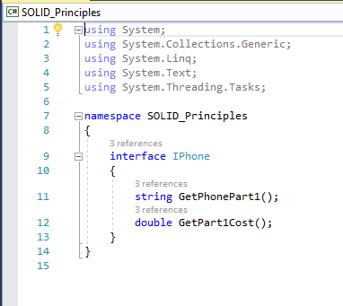

**Implementation of the Interface**

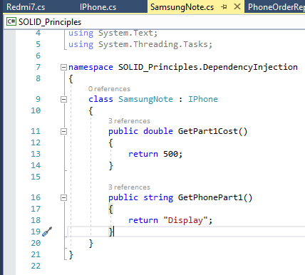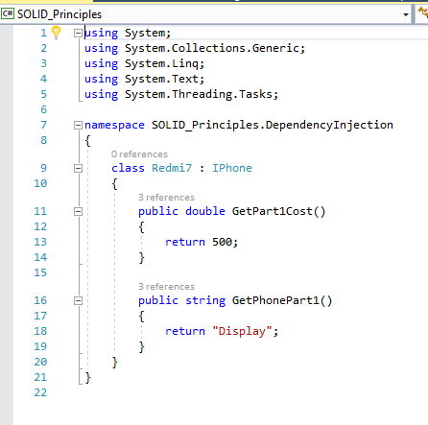

**Class that takes in the phone object as dependency**

